Contents
1. Overview 3
1.1 Purpose and outputs 3
1.2 Generate on Server 3
1.3 How it works at a glance 3
2. System Architecture 4
2.1 Layer responsibilities 4
3. End-to-End Process Flow 5
4. Master Data Tables 6
4.1 Lookup tables 6
4.2 Matching rules and legacy data 7
5. Drawing Generation Detail 7
5.1 Sheet 1 — General Arrangement 7
5.2 Sheet 2 — Cross-Section reference drawing 8
5.3 Sheet 3 — Nameplate 8
5.4 Finishing 8
6. Progress Tracking & Error Reporting 9
6.1 Progress milestones 9
6.2 Error reporting 9
6.3 SolidWorks session lifecycle 9
7. Technical Implementation Notes 10
7.1 COM connection (early binding) 10
7.2 Dynamic vs. early-bound return values 10
7.3 Copying a sheet from another document 10
7.4 Threading 11
8. Configuration Reference 11
9. Glossary 12

1. Overview
The Globe GAD Automation module generates a General Arrangement Drawing (GAD) for Series 10/11 Globe control valves directly from a valve Bill of Materials (BOM) row, driving SolidWorks over COM automation. It is a Python/Flask re-implementation of logic that previously lived in a standalone WinForms desktop application, and it is now exposed as a web page that any authorized user can run from a browser.

1.1 Purpose and outputs
Two output files are produced for every generation and delivered together as a single .zip download:
Output | Description
3-page PDF drawing | The finished drawing: Sheet 1 General Arrangement, Sheet 2 Cross-Section reference drawing and Sheet 3 Nameplate.
Native SolidWorks drawing | The same drawing in SolidWorks’ native .SLDDRW format.

Highlights
- Browser-based — runs as a web page for any authorized user.
- Data-driven — drawing numbers, dimensions and title-block values are resolved from five master lookup tables.
- Live feedback — progress is streamed step by step while the drawing is being built.
- Actionable errors — a failed lookup names the exact master table to fix and links straight to it.

1.2 Generate on Server
The single supported generation path runs entirely on whichever machine hosts the Flask app, provided that machine has SolidWorks installed and licensed. Clicking Generate on Server starts a background job on that machine; progress is streamed to the browser in real time until both output files are ready to download.
REQUIREMENT The host machine must have SolidWorks installed and licensed. Generation does not run anywhere else.

1.3 How it works at a glance
STEP 1  Upload & edit  Upload the valve BOM Excel, pick a row and edit its values in the browser. | STEP 2  Resolve  The server matches the row against the 5 master lookup tables. | STEP 3  Build  A background job drives SolidWorks to build the 3-sheet drawing. | STEP 4  Download  The PDF and the native .SLDDRW arrive together as one .zip.

The full step-by-step flow, including the master-data validation loop, is shown in section 3.

2. System Architecture
The application is a standard Flask web app backed by PostgreSQL, with a dedicated automation layer that talks to SolidWorks through the pywin32 COM bridge. Database access and SolidWorks automation are kept cleanly separated.
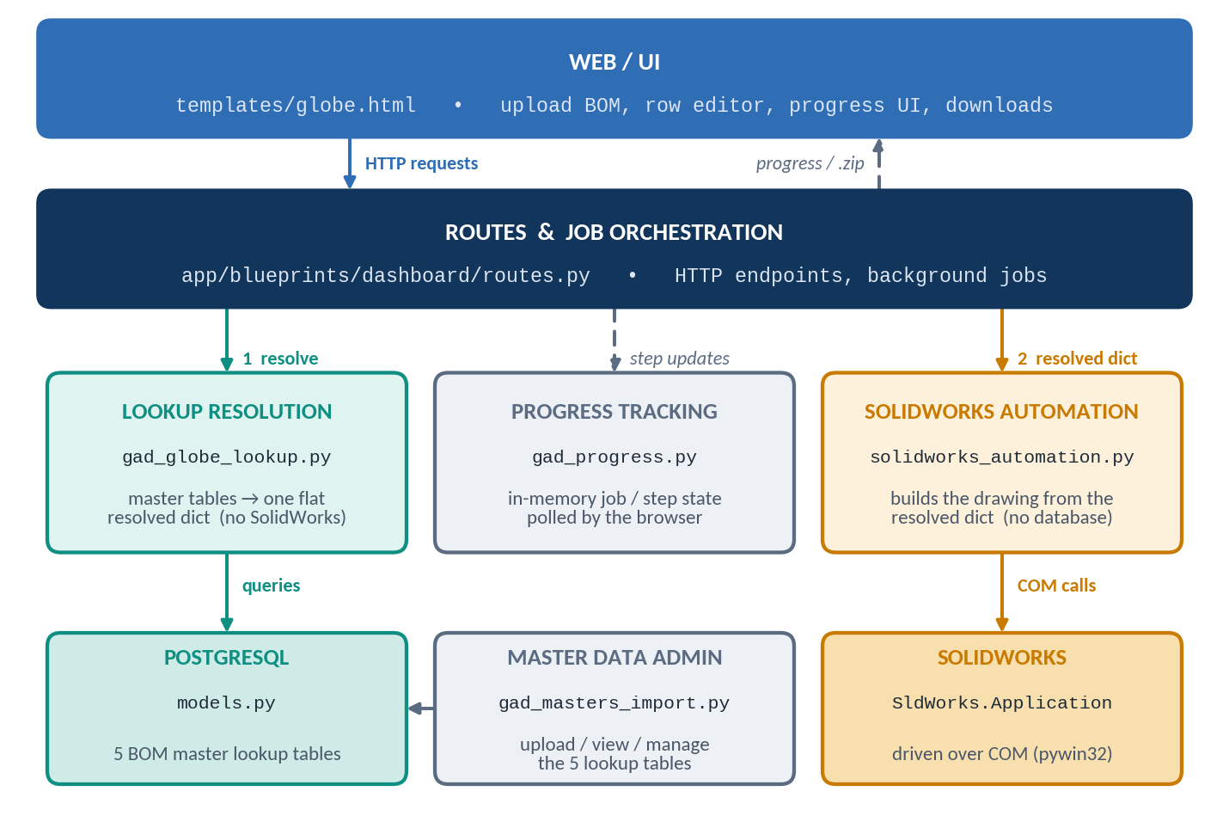
Figure 1 — Application layers and how they connect

2.1 Layer responsibilities
Layer | Responsibility | Key file(s)
Web / UI | Upload BOM, row editor, progress UI, downloads | templates/globe.html
Routes | HTTP endpoints, background job orchestration | app/blueprints/dashboard/routes.py
Lookup resolution | Master-table queries → one flat resolved dict (no SolidWorks dependency) | app/services/gad_globe_lookup.py
SolidWorks automation | COM automation that builds the drawing (no database dependency) | app/services/solidworks_automation.py
Progress tracking | In-memory job/step state for the browser to poll | app/services/gad_progress.py
Master data admin | Upload, view and manage the 5 lookup tables | app/services/gad_masters_import.py
Database | PostgreSQL — BOM master lookup tables | app/models.py
DESIGN PRINCIPLE Resolve first, then automate. The SolidWorks automation layer works purely on the already-resolved dict it is handed and has no database dependency, which makes it straightforward to test and reason about in isolation from the web and database side of the app.

3. End-to-End Process Flow
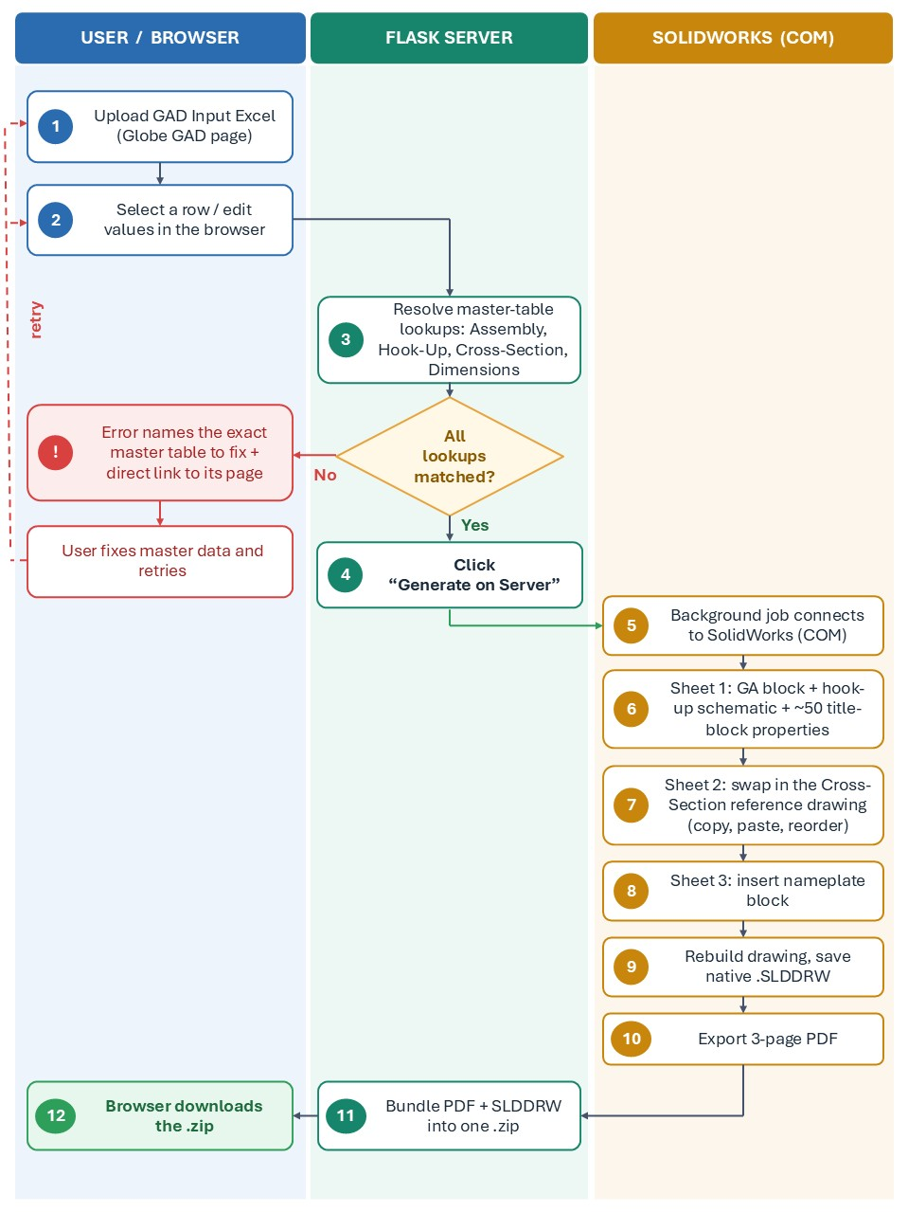
The diagram traces one Generate on Server click from the browser through to the downloaded file, including the master-data validation loop.

4. Master Data Tables
Every generation resolves the incoming BOM row against 5 lookup tables, each manageable through the “Globe GAD Masters” admin pages (upload Excel sheet, view and filter existing rows). A row that doesn’t match any master-table entry fails generation immediately with an error naming the exact table to fix.

4.1 Lookup tables

1 Overall Assembly
FEEDS | Sheet 1 — GA block
MODEL / DB TABLE | GAGlobeTable · ga_globe_table
MATCH KEYS | valve_series, body_style, valve_size, rating, end_connection, bonnet_type, flow_direction, actuator_series, actuator_type, actuator_size, traval_stop, hw
RETURNS | drawing_no (the GA block .SLDBLK)

2 Hook-Up Selection
FEEDS | Sheet 1 — hook-up schematic
MODEL / DB TABLE | GAGlobeHookUp · ga_globe_hookup
MATCH KEYS | actuator, spring, air_fail_action, positioner, hand_auto, limit_switch, position_trans, volume_booster, spool_valve, lock_valve, solenoid_valve
RETURNS | schematic_no

3 Cross-Section (formerly “Sheet4 Selection”)
FEEDS | Sheet 2 — whole reference drawing
MODEL / DB TABLE | GASheet4Globe · ga_sheet4_globe
MATCH KEYS | body_style, end_connection, size, rating, bonnet_type, trim_type, balancing, flow_direction, bal_seal_type, seat_type, packing_type
RETURNS | drawing_no (the reference drawing, e.g. CS0xx.SLDDRW)

4 Valve Dimensions
FEEDS | Title block — dimensions A / B / C / AR and weight
MODEL / DB TABLE | GADimValveGlobe · ga_dim_valve_globe
MATCH KEYS | body_style, end_connection, bonnet_type, end_finish, series, size, rating, stem_dia
RETURNS | Dimensions A, B, C, AR and weight

5 Actuator Dimensions
FEEDS | Title block — dimensions D / E / F and weight
MODEL / DB TABLE | GADimActGlobe · ga_dim_act_globe
MATCH KEYS | actuator_type, actuator_size, hand_wheel, travel_stop
RETURNS | Dimensions D, E, F and weight

4.2 Matching rules and legacy data
SIZE / RATING MATCHING The Overall Assembly and Cross-Section tables allow a single cell to hold a comma-separated list of valid values (e.g. size 1,4 or rating ASME 150,ASME2500). A BOM row matches if its value appears anywhere in that list, independent of spacing.
LEGACY TABLE GACrossSecGlobe (ga_crosssec_globe) previously fed the old Sheet 2 cross-section block and is no longer queried by generation. Sheet 2 is now built entirely from the Cross-Section table. The legacy table remains in the database, unused rather than deleted, in case of a future revert.

5. Drawing Generation Detail
SolidWorks automation opens one shared .DRWDOT template per generation and builds three sheets before rebuilding and exporting. All COM automation runs inside a single global lock, since SolidWorks can only drive one document build at a time.
Sheet | Content | Driven by | Method
Sheet 1 | General Arrangement: GA block, hook-up schematic, ~50 title-block properties | Overall Assembly, Hook-Up, Valve & Actuator Dimensions | .SLDBLK inserts + custom properties
Sheet 2 | Cross-Section reference drawing | Cross-Section | Whole-sheet copy / paste
Sheet 3 | Nameplate | None — fixed file | .SLDBLK insert

5.1 Sheet 1 — General Arrangement
- Insert the GA block (.SLDBLK, looked up via Overall Assembly) at a fixed position.
- Insert the hook-up schematic block (.SLDBLK, looked up via Hook-Up Selection).
- Push ~50 custom properties onto the title block: customer, project, tag no, dimensions A / B / C / AR / D / E / F, weight, materials, and more.

5.2 Sheet 2 — Cross-Section reference drawing
Sheet 2 no longer inserts a .SLDBLK block. Instead, the whole reference drawing (a separate .SLDDRW file, e.g. CS001.SLDDRW) is copied in wholesale, replacing the template’s own Sheet 2 tab outright.
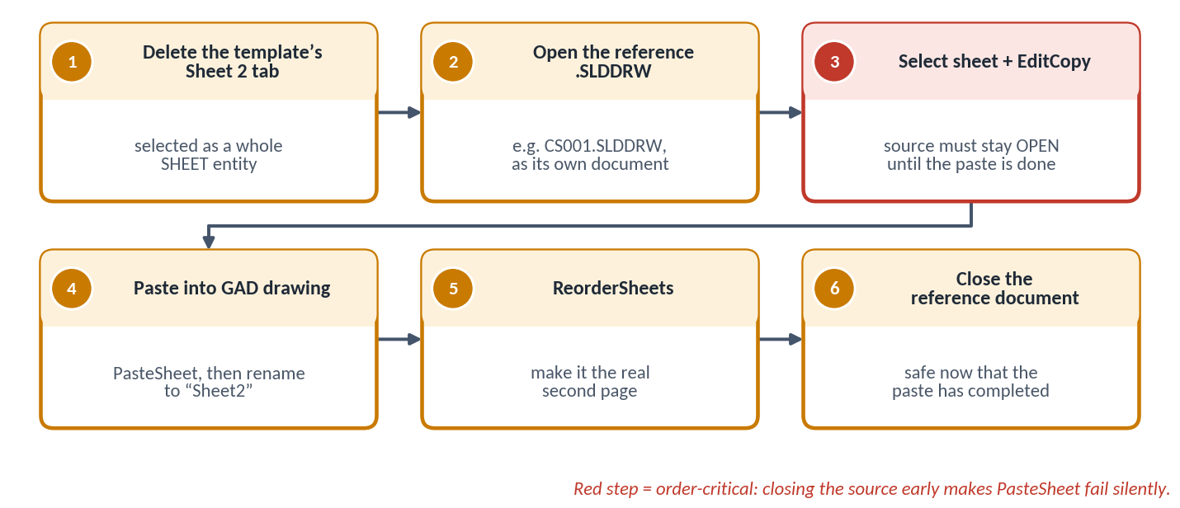
Figure 3 — Sheet 2 swap sequence
ORDER-CRITICAL The source document must stay open until after the paste completes, or the paste silently fails. See section 7.3 for the related COM quirks.

5.3 Sheet 3 — Nameplate
Inserts a fixed nameplate block (.SLDBLK). It is the same file on every generation and is not looked up per row.

5.4 Finishing
- Rebuild the full drawing (ForceRebuild3).
- Save the native SolidWorks drawing (.SLDDRW).
- Export the 3-page PDF from the same document.
- Bundle both files into one .zip and mark the job downloadable.

6. Progress Tracking & Error Reporting

6.1 Progress milestones
Generate on Server runs the SolidWorks automation in a background thread rather than blocking the HTTP request, so the browser can poll for real step-by-step progress instead of showing one long spinner.
Step | Milestone shown to the user | Phase
1 | Connecting to SolidWorks | Setup
2 | Opening GAD template | Setup
3–4 | Sheet 1: inserting GA block / hookup schematic | Sheet 1
5 | Sheet 1 complete — title block properties set | Sheet 1
6 | Sheet 2 complete — reference drawing inserted | Sheet 2
7 | Sheet 3 complete — nameplate inserted | Sheet 3
8 | Rebuilding drawing | Finish
9 | Exporting PDF | Finish

6.2 Error reporting
If any master-table lookup fails, the error names the exact GAD Masters table responsible (for example, “No matching row found in the Cross-Section master table…”) and the browser shows a direct link to that table’s admin page, rather than a generic failure message.
RESULT The user goes straight from the error to the table that needs fixing, corrects the data, and retries — no log digging required.

6.3 SolidWorks session lifecycle
Once generation succeeds, SolidWorks is intentionally left open (visible) so the user can inspect the drawing.
Trigger | Result
Generation succeeds | SolidWorks stays open and visible for inspection.
User dismisses the success message | SolidWorks closes. The in-memory copy is discarded with no save prompt.
Tab abandoned | SolidWorks closes after a 20-minute safety timeout.

7. Technical Implementation Notes
SolidWorks’ COM API has several undocumented quirks that required empirical verification against a live SolidWorks session. They are recorded here for future maintainers.

7.1 COM connection (early binding)
Symptom / behaviour | Fix / rule
pywin32’s normal gencache.EnsureDispatch() fails against SldWorks.Application with “This COM object can not automate the makepy process”. SolidWorks’ GetTypeInfo() call doesn’t behave the way EnsureDispatch expects. | Read both required type libraries (sldworks.tlb and swconst.tlb) directly from the registry by their stable GUIDs, build the wrapper modules explicitly, and create the instance with a plain Dispatch() — avoiding the failing lookup entirely.

7.2 Dynamic vs. early-bound return values
Symptom / behaviour | Fix / rule
NewDocument() and GetMathUtility() declare a plain IDispatch return type, so their results are only partially usable via dynamic dispatch. Calling members such as ActivateSheet or InsertSketch fails with “Member not found”. | Explicitly re-wrap each such result as its known interface class (ModelDoc2, DrawingDoc, MathUtility) before use.

7.3 Copying a sheet from another document
Symptom / behaviour | Fix / rule
PasteSheet silently returns False if the source document was already closed — even immediately after EditCopy(). The “sheet on the clipboard” depends on the source document staying alive, not on a plain OS clipboard payload. | Keep the source document open until after the paste completes.
PasteSheet always inserts the new sheet immediately after Sheet 1, regardless of which sheet was selected as the anchor. | Fix the final ordering explicitly afterwards with ReorderSheets.
ReorderSheets silently returns False when given a plain Python list, which marshals as the wrong VARIANT subtype. | Pass the argument as a SAFEARRAY of BSTR (VT_ARRAY | VT_BSTR).
Deleting a sheet (Extension.DeleteSelection2) disconnects pywin32’s cached ModelDoc2 / DrawingDoc references (“the object invoked has disconnected from its clients” on the next call). | Re-wrap fresh references from sw_app.ActiveDoc afterwards.

7.4 Threading
Symptom / behaviour | Fix / rule
COM requires the calling thread to have an initialized apartment before any Dispatch() call. This happens automatically on a plain script’s main thread, but not on a Flask request or background thread. | Call pythoncom.CoInitialize() in the thread before any Dispatch().
SolidWorks can only drive one document build at a time. | A single process-wide lock serializes the drawing-build steps. It is released before the post-success wait for the user’s acknowledgment, so one open drawing doesn’t block others.

8. Configuration Reference
All file and folder locations are environment variables (.env), needed only on the machine that actually runs the SolidWorks automation.
Variable | Purpose | Used by
GAD_TEMPLATE_PATH | The shared .DRWDOT template opened for every generation. | All sheets
GAD_BLOCK_DIR | Folder of GA blocks (.SLDBLK) for Sheet 1, keyed by drawing_no. | Sheet 1
GAD_HOOKUP_BLOCK_DIR | Folder of hook-up schematic blocks (.SLDBLK) for Sheet 1. | Sheet 1
GAD_NAMEPLATE_BLOCK_PATH | The single fixed nameplate block (.SLDBLK) for Sheet 3. | Sheet 3
GAD_SHEET4_DIR | Folder of whole reference drawings (.SLDDRW) for Sheet 2, keyed by the Cross-Section table’s drawing_no. | Sheet 2
GAD_OUTPUT_DIR | Where the PDF / .SLDDRW pair are written before zipping. Falls back to the Desktop, then a temp folder, if unset or invalid. | Output
DATABASE_URL | PostgreSQL connection string for all master lookup tables. | Lookups
Example .env layout (replace the placeholders with your own paths):
GAD_TEMPLATE_PATH=<path to the .DRWDOT template>
GAD_BLOCK_DIR=<folder of GA blocks>
GAD_HOOKUP_BLOCK_DIR=<folder of hook-up schematic blocks>
GAD_NAMEPLATE_BLOCK_PATH=<path to the nameplate .SLDBLK>
GAD_SHEET4_DIR=<folder of cross-section reference drawings>
GAD_OUTPUT_DIR=<output folder>
DATABASE_URL=<PostgreSQL connection string>

9. Glossary
Term | Meaning
GAD | General Arrangement Drawing — the overall assembly drawing of the valve.
BOM | Bill of Materials — the uploaded Excel row describing one valve configuration.
COM | Component Object Model — the Windows automation interface SolidWorks exposes.
.SLDDRW | SolidWorks’ native drawing document file format.
.SLDBLK | A SolidWorks sketch block file — reusable 2D content inserted onto a sheet.
.DRWDOT | SolidWorks drawing template file, opened once per generation.
Master table | One of the 5 PostgreSQL lookup tables managed through the Globe GAD Masters admin pages.
Resolved dict | The flat, database-free result of resolve_globe_gad() — drawing numbers, dimension values and title-block properties for one BOM row.

